Dialectal Synonyms

🔹 What is Dialectal Synonyms
# Source: AI Source: Provided by: [Data Path: Persons Table -> ID Column: 1, Name_En Column: Motasem Essam] -> From: [Chatgpt (GPT-4-turbo)] on [7/30/2025]
Dialectal synonyms are words with the same or similar meaning that are used in different regional dialects or varieties of a language. These synonyms are region-specific and may not be universally understood across all speakers of the language.

🧠 Definition:
# Source: AI Source: Provided by: [Data Path: Persons Table -> ID Column: 1, Name_En Column: Motasem Essam] -> From: [Chatgpt (GPT-4-turbo)] on [7/30/2025]
Dialectal synonyms are alternative words for the same concept that vary depending on geographical region, social group, or language variety.
They reflect how the same idea is expressed differently in different dialects (e.g., British English vs. American English).

📌 Key Features:
# Source: AI Source: Provided by: [Data Path: Persons Table -> ID Column: 1, Name_En Column: Motasem Essam] -> From: [Chatgpt (GPT-4-turbo)] on [7/30/2025]
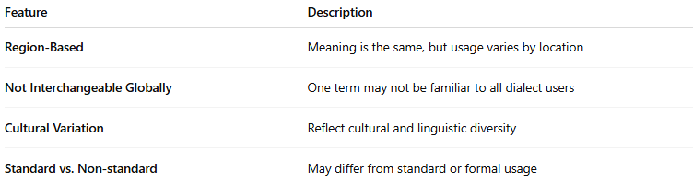
Feature | Description
Region-Based | Meaning is the same, but usage varies by location
Not Interchangeable Globally | One term may not be familiar to all dialect users
Cultural Variation | Reflect cultural and linguistic diversity
Standard vs. Non-standard | May differ from standard or formal usage

📚 Examples of Dialectal Synonyms:
# Source: AI Source: Provided by: [Data Path: Persons Table -> ID Column: 1, Name_En Column: Motasem Essam] -> From: [Chatgpt (GPT-4-turbo)] on [7/30/2025]
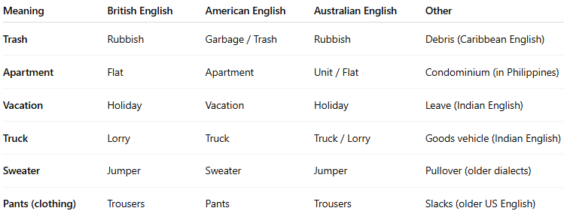
Meaning | British English | American English | Australian English | Other
Trash | Rubbish | Garbage / Trash | Rubbish | Debris (Caribbean English)
Apartment | Flat | Apartment | Unit / Flat | Condominium (in Philippines)
Vacation | Holiday | Vacation | Holiday | Leave (Indian English)
Truck | Lorry | Truck | Truck / Lorry | Goods vehicle (Indian English)
Sweater | Jumper | Sweater | Jumper | Pullover (older dialects)
Pants (clothing) | Trousers | Pants | Trousers | Slacks (older US English)

🧾 Notes:
# Source: AI Source: Provided by: [Data Path: Persons Table -> ID Column: 1, Name_En Column: Motasem Essam] -> From: [Chatgpt (GPT-4-turbo)] on [7/30/2025]
- Dialectal synonyms often lead to confusion or humor in cross-cultural communication.
- They also reflect sociolinguistic identity and language evolution.

🔁 Comparison with Other Synonyms:
# Source: AI Source: Provided by: [Data Path: Persons Table -> ID Column: 1, Name_En Column: Motasem Essam] -> From: [Chatgpt (GPT-4-turbo)] on [7/30/2025]
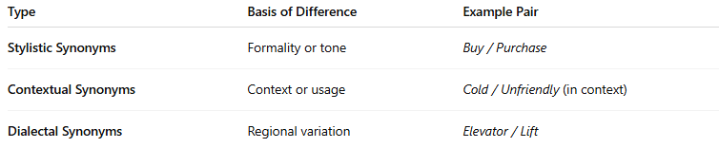
Type | Basis of Difference | Example Pair
Stylistic Synonyms | Formality or tone | Buy / Purchase
Contextual Synonyms | Context or usage | Cold / Unfriendly (in context)
Dialectal Synonyms | Regional variation | Elevator / Lift

